**Project 1: Joystick controlled Obstacle Avoiding Robot**

INTRODUCTION:

Robotics is an interesting and fast-growing field. Being a branch of engineering, the applications of robotics are increasing with the advancement of technology.

The concept of Mobile Robot is fast evolving and the number of mobile robots and their complexities are increasing with different applications.

There are many types of mobile robot navigation techniques like path planning, self – localization and map interpreting. An Obstacle Avoiding Robot is a type of autonomous mobile robot that avoids collision with unexpected obstacles.

In this project, an Obstacle Avoiding Robot controlled by a bluetooth enabled joystick is designed. It is an

Arduino based robot that uses Ultrasonic range finder sensors to avoid collisions.

HARDWARE REQUIRED:

**Joystick**

Arduino Nano

Bluetooth Module- HC-05

Gyro+Accelerometer Sensor- MPU-6050

Battery – 6LR61 (9V)

Jumper Wires

COMPONENT DESCRIPTION:

**1. Arduino Nano**

The Arduino Nano has a number of facilities for communicating with a computer,

another Arduino, or other microcontrollers. The ATmega328 provide UART TTL (5V)

serial communication, which is available on digital pins 0 (RX

and 1 (TX).

Each of the 14 digital pins on the Nano can be used as an input or output, using pinMode(), digitalWrite(), and digitalRead() functions. They operate at 5 volts. Each pin can provide or receive a maximum of 40 mA and has an internal pull-up resistor (disconnected by default) of 20-

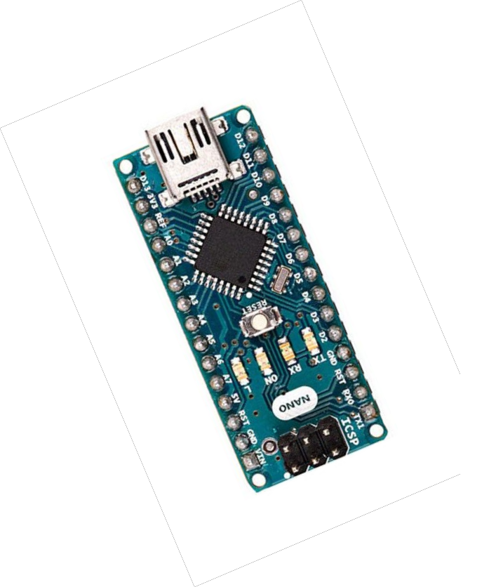50 kOhms

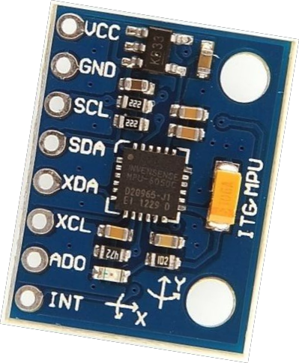**2. Gyro+Accelerometer Sensor- MPU-6050**

The MPU-60X0 is the world’s first integrated 6-axis MotionTracking device that combines a 3-axis gyroscope, 3-axis accelerometer, and a Digital Motion Processor™ (DMP)

The MPU-60X0 features three 16-bit analog-to-digital converters (ADCs) for digitizing the gyroscope outputs and three 16-bit ADCs for digitizing the accelerometer outputs. For precision tracking of both fast and slow motions, the parts feature a user-programmable gyroscope full-scale

range of ±250, ±500, ±1000, and ±2000°/sec (dps) and a user- programmable accelerometer full-scale range of ±2g, ±4g, ±8g, and ±16g.

**CIRCUIT DIAGRAM**:

**2. Joystick**

**Schematic View**

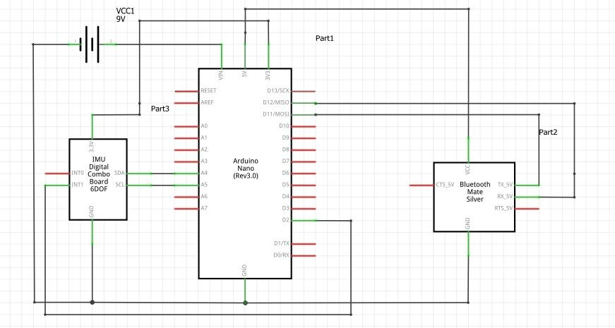

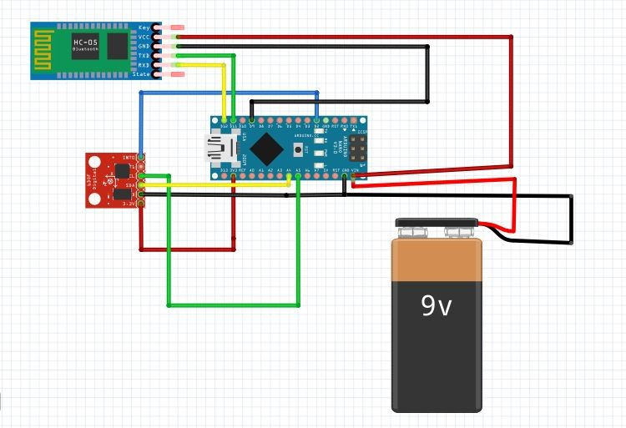

APPLICATIONS:

With proper programming, we can use it as a weight lifter, auto parking assistance.

By making small changes in software this system can be used for avoiding concealed paths.

GALLERY:

**JOYSTICK**

